Contents
Engagement At A Glance 1
Executive Summary 2
Key Themes 2
Engagement Overview 3
Engagement Evaluation 3
Caveats and Limitations 3
Next Steps 4
Detailed Phase 3 Engagement Report 5
What We Asked 5
What We Heard 6
1. Community Advisory Panel #3: July 30, 2024 6
Conclusion 7
Appendix A: Engagement at a Glance – Phase 1 and 2 9
Appendix B: Participant Engagement Feedback 11

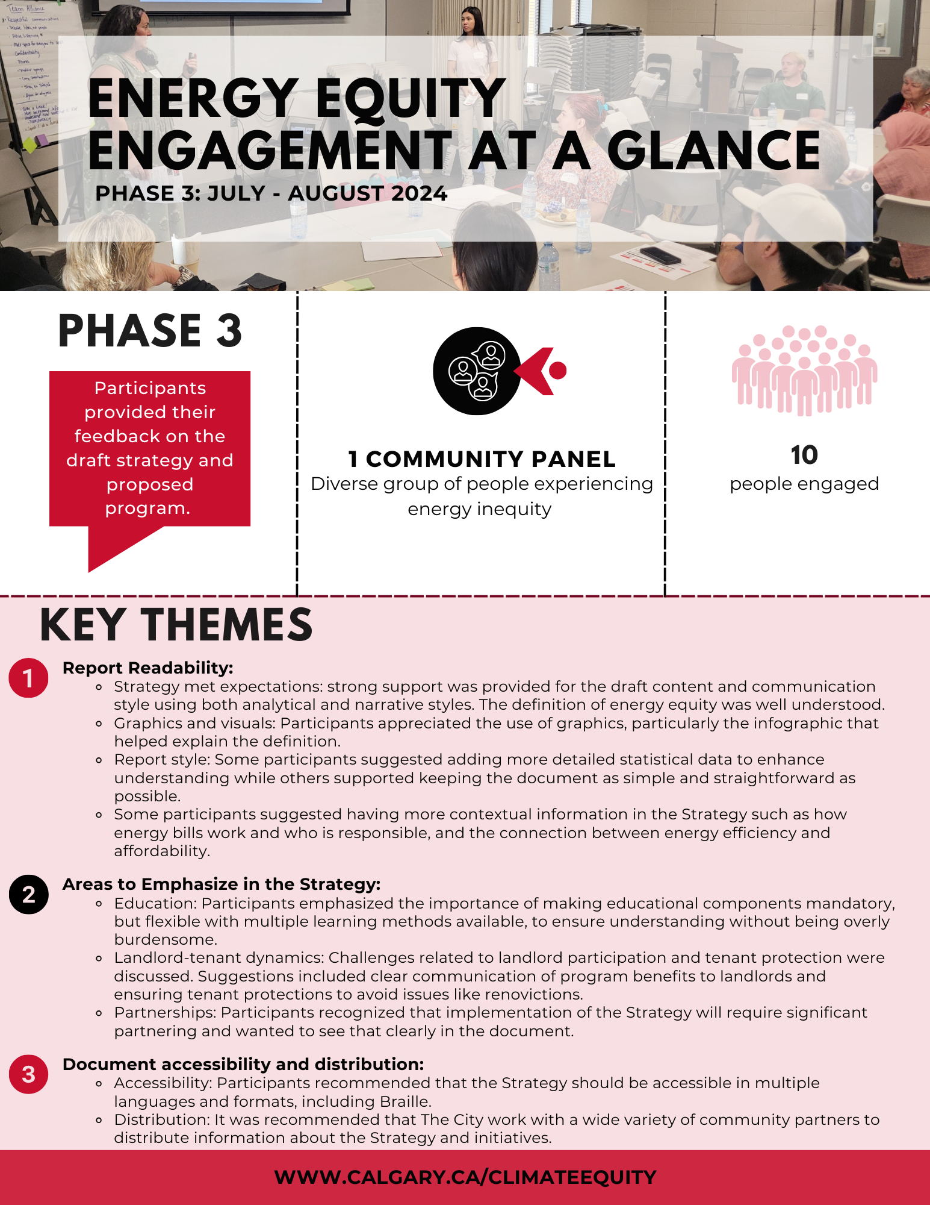
Engagement At A Glance

Executive Summary
In 2022, The City of Calgary (The City) declared a climate emergency and created the Calgary Climate Strategy – Pathways to 2050. In Calgary, approximately 64,000 households struggle with energy inequity each year. Experiencing energy inequity means that people find it hard to afford basic utilities like heating and electricity and spend more of their income on these essentials compared to others. The Climate Strategy states that to be on track to achieve net zero by 2050, the number of households struggling to afford energy should be reduced by half by 2030 and all Calgarians should comfortably afford their home energy by 2050.
To address energy inequity, key actions for The City are to create an Energy Equity Strategy and incentive program for Calgary.
This report summarizes the findings from the final community advisory panel meeting as part of the Energy Equity Strategy’s Phase 3 engagement.

Key Themes
On July 30, 2024, the final Community Advisory Panel meeting was held to review the draft Energy Equity Strategy. The purpose of the meeting was to gather feedback on the draft Strategy and the proposed program approach. The meeting involved discussions on various aspects of the strategy, including its clarity, priorities, implementation framework, and overall effectiveness.
- Report readability:
  - Strategy met expectations: Strong support was provided for the draft content and communication style using both analytical and narrative styles. The definition of energy equity was well understood.
  - Graphics and visuals: Participants appreciated the use of graphics, particularly the infographic that helped explain the definition.
  - Report style: Some participants suggested adding more detailed statistical data to enhance understanding while others supported keeping the document as simple and straightforward as possible.
  - Some participants suggested having more contextual information in the Strategy such as how energy bills work, who is responsible and the connection between energy efficiency and affordability.
- Areas to emphasize in the strategy:
  - Education: Participants emphasized the importance of making educational components mandatory, but flexible with multiple learning methods available, to ensure understanding without being overly burdensome.
  - Landlord-tenant dynamics: Challenges related to landlord participation and tenant protection were discussed. Suggestions included clear communication of program benefits to landlords and ensuring tenant protections to avoid issues like renovictions.
  - Partnerships: Participants recognized that implementation of the Strategy will require significant partnering and wanted to see that clearly in the document.
- Document accessibility and distribution
  - Accessibility: Participants recommended that the Strategy should be accessible in multiple languages and formats, including Braille.
  - Distribution: It was recommended that The City work with a wide variety of community partners to distribute information about the Strategy and initiatives.

Engagement Overview
The Energy Equity Strategy was developed with feedback from community engagement through three phases. This What We Heard Report reports on Phase 3. For reference, the Engagement At A Glance sections from Phases 1 and 2 are included in Appendix A: Engagement at a Glance – Phase 1 and 2.
- Phase 1 Engagement: Understand Options
Timeline: October – December 2023
Objective: Listened and learned from people's experiences to confirm the challenges and understand what solutions should be prioritized.
Actions:
- Workshops with organizations, utilities, and non-market housing.
- Community Panel that included diverse people who have experienced energy inequity.
- Five focus groups to understand how communities are impacted differently.
- An online and paper survey.
- Phase 2 Engagement: Refine Solutions
Timeline: February – April 2024
Objective: Presented solutions identified in Phase 1 and gathered feedback to refine the solutions and discussed the draft strategy framework.
Actions:
- Organizations and non-market housing workshop
- Community Advisory Panel
- Older Adult Table
- Social Well-being Committee

- Phase 3 Engagement: Draft Energy Equity Strategy
Timeline: July 2024
Objective: Presented the draft strategy to see if it reflected the feedback and learnings gathered and to collect further feedback.
Actions:
- Community Advisory Panel

Engagement Evaluation
The City of Calgary asked participants to provide feedback on the engagements. Please see Appendix B: Participant Engagement Feedback.

Caveats and Limitations
The City of Calgary is one level of government and may lack the ability to make direct changes in some areas. With The City’s limited control over some of the factors that contribute to energy inequity and the solutions to address it, we will strive to advocate for and collaborate with interested parties on solutions. Areas where The City has direct control, we will actively strive to find and implement solutions.
All the input collected for this project should be considered through the lens of what will work best in Calgary.

Next Steps
The community advisory panel’s feedback on the draft Strategy will be considered alongside additional reviews and the project team will prepare a final Energy Equity Strategy. Once the document is finalized, a webinar will be hosted and made available publicly for anyone who wishes to learn about the final Energy Equity Strategy and upcoming programs.

Detailed Phase 3 Engagement Report
The third phase of the engagement included:
- One final engagement session with the Community Advisory Panel (10 people)

What We Asked
In the engagement workshop, the project team provided project updates, an overview of the draft Strategy framework, and a draft of how one of the incentive programs might work. Discussions took place that were guided by, but not limited to the following questions:
The Overall Strategy
- What are your overall impressions of the draft Strategy?
- Is the Strategy understandable? Clear in its goals?
Why is Energy Equity Important?
- Is the concept of energy equity explained clearly?
- Does the Strategy convey why energy equity is important for Calgarians?
- Do you think the “What we Heard” section accurately reflects the community feedback?
The Plan
- What are your thoughts on the vision, mission, targets and principles?
- Do the initiatives address the most pressing energy equity issues?
- Is The City role clear?
- Do you think anything should be added, changed, or removed to better achieve the Strategy’s goals?
- Is the implementation framework practical and clear?
- Are there any foreseeable barriers that should be addressed for implementation?
- Are we missing anything?
The Program Approach
- What are your thoughts on the program approach?
- Does this offer the support people are looking for?
- Do you think there might be any unintended negative consequences, or potential barriers to participation?
- Should education be mandatory?
- Do you have recommendations for changes? (missing, added, removed)
This feedback is not statistically representative of all Calgarians, so participants will be called participants, not Calgarians.

What We Heard
The following section highlights the primary themes from the engagement session.

Community Advisory Panel #3: July 30, 2024
10 members attended this meeting.
The Overall Strategy
- Participants generally found the Strategy to be clear, understandable for the public and with useful supporting graphics. Participants particularly liked the dollar bill image. The executive summary was supported by the participants.
- There were questions about who the audience is and whether the Strategy can be more directed to the target audience. Discussion on this point was that the executive summary/infographic is for the public, and the rest of the document is for a wide range of audiences.
- There was support for the updated land acknowledgement that is more specific about both the land, the Peoples of the region and the link to the Strategy.
- Some individuals suggested adding more detailed statistics and links to more comprehensive information while others wanted to maintain the shorter length of the document.
- It was suggested to convert some text into graphics and keep it as simple and straightforward as possible.
- There was strong support for the stories in the Strategy and the informal parts that allow people to feel connected to the work.
- Recommendations were made to ensure the document is accessible through various formats including audio and braille and is distributed through a wide variety of networks including non-City locations such as banks, schools, etc. For example, Indigenous Peoples coming to Calgary from a reserve won’t know how the municipal system works and so the information needs to be available through non-municipal sources to reach the people who need it most.
- A recommendation was made to emphasize the importance of partnerships in the Strategy.
Why is Energy Equity Important
- Participants thought the concept of energy equity was well-explained but requested more statistical data to highlight the impact of rising energy costs on Calgarians (i.e., increasing climate risks).
- Linking energy equity to broader issues such as climate change, wellbeing, and quality of life was suggested to provide a more comprehensive understanding. Participants recommended linking energy efficiency and affordability together better – how improving energy efficiency helps affordability and how much impact it has.
- There was agreement that including the eligibility criteria in the Strategy would be useful.
The Plan
- Participants had positive feedback on the draft vision, mission, and guiding principles, as well as the mix of quantitative and qualitative approaches.
- Recommendations were made to include discussion in the Strategy about how utility bills, rates and the energy system works including what organizations are responsible for the different fees on energy bills.
- It was recommended that affordability should be a higher priority than energy efficiency because if energy is more affordable then homeowners might be able to manage energy efficiency on their own.
- There was strong agreement to make the role of education more explicit. In the words of one participant, “without education, the aspirational targets become a dream that never comes true”.
- Concern was raised about how to ensure landlords don’t increase rents or issue eviction notices after receiving energy efficiency supports. One participant asked whether there could there be a map or online information about properties that are enrolled in the program.
- It was recommended that retrofits can be made by the homeowner rather than requiring a contractor.
- Participants suggested continuing to pursue data sharing with utilities.
- The importance of ongoing evaluation was recognized so that adjustments can be made to ensure the Strategy remains effective. Participants noted that running the programs as pilots allows for quick and efficient adjustments if something isn’t working the way it is intended.
- There was concern that this program could be used by scammers mimicking the program. The City should consider how to verify the program and any staff/contractors associated with it.
- One participant asked whether there is a way to determine how the homes will be more energy efficient. Is there a way to label a house based on energy efficiency so renters know what they are dealing with? Discussion was held about The City’s home energy labelling program.
- One participant raised the idea that could The City reduce taxes for homeowners who improve their home energy efficiency.
Draft Program Approach
- There was general agreement that the program approach is good.
- Participants noted a strong emphasis on the need for mandatory education in a variety of formats – in person and online. Education can be on both energy efficiency in general and how the program will work and what will be required of participants. They recommended that any education be called awareness training rather than educational training because education feels too formal and intimidating.
- There was support for having 6 months of utility subsidy, but a recommendation to make it longer, or more flexible to consider whether they are summer or winter costs that are subsidized.
- Concerns were raised about potential barriers to participation, particularly for non-standard living arrangements (e.g., Multigenerational families with many people living in a home, but only a few who have incomes) and individuals with disabilities.
- There is support for using existing programs (i.e., Fair Entry) for access to climate programming.

Conclusion
The feedback from the final Community Advisory Panel meeting highlights that the draft Strategy largely aligned with their expectations and some key changes or areas to emphasize included:
- the need for the document to be accessible and useful to multiple audiences including some audiences that need a short summary, and others who will want more detailed information.
- Requiring mandatory education.
- Emphasizing partnerships, ongoing and timely program evaluation, and
- Adding information about program eligibility and how the energy system works including information on utility bills.
- Ensuring that the Strategy is distributed widely throughout the city in a variety of formats.

Next Steps
- Finalize the Energy Equity Strategy incorporating the feedback received.
- Prepare for the public release of the strategy and its implementation plan.

The City of Calgary would like to thank all participants for taking the time to prepare for and participate in the engagement session and for providing candid feedback and recommendations. The City of Calgary will be reviewing all feedback to incorporate these perspectives where appropriate into the Energy Equity Strategy.

Appendix A: Engagement at a Glance – Phase 1 and 2
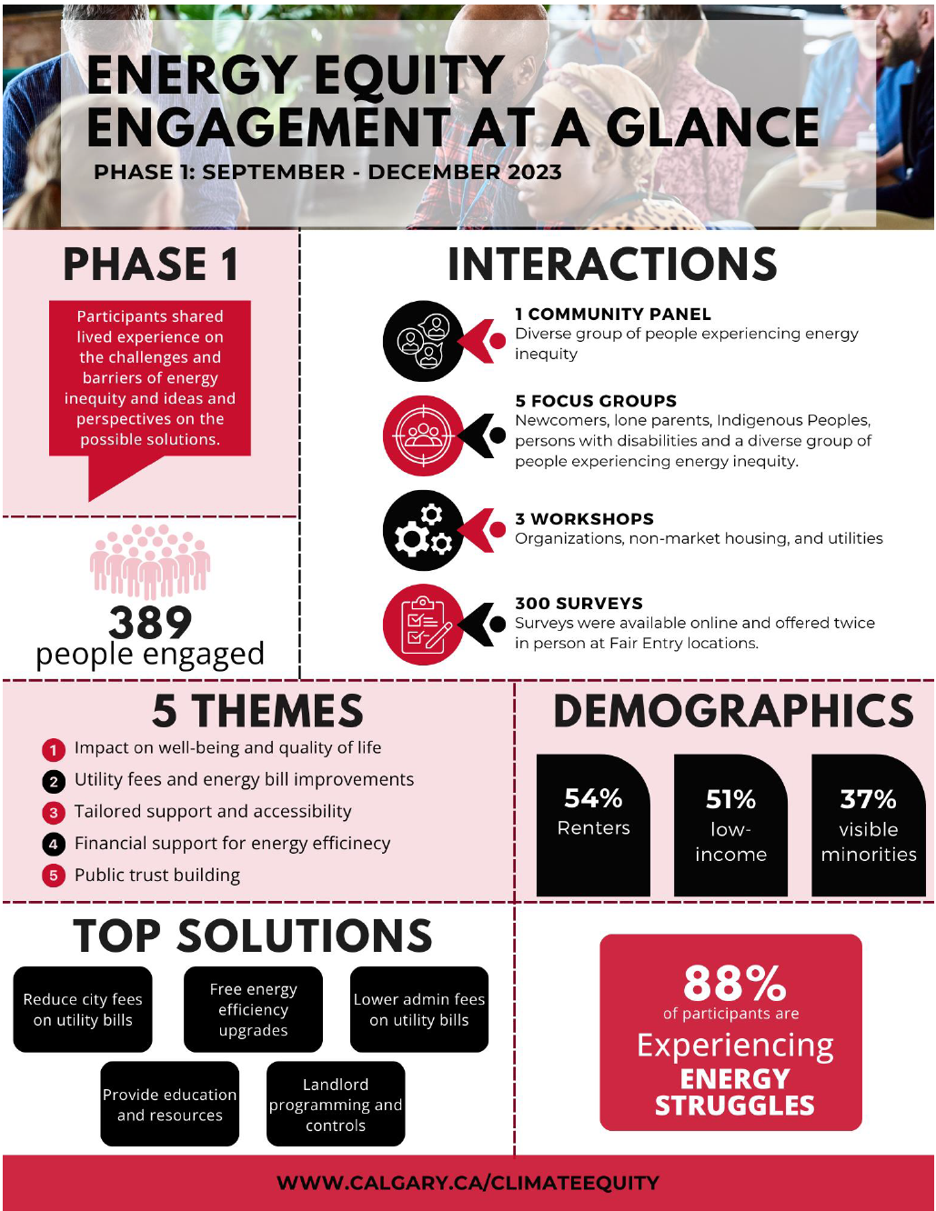
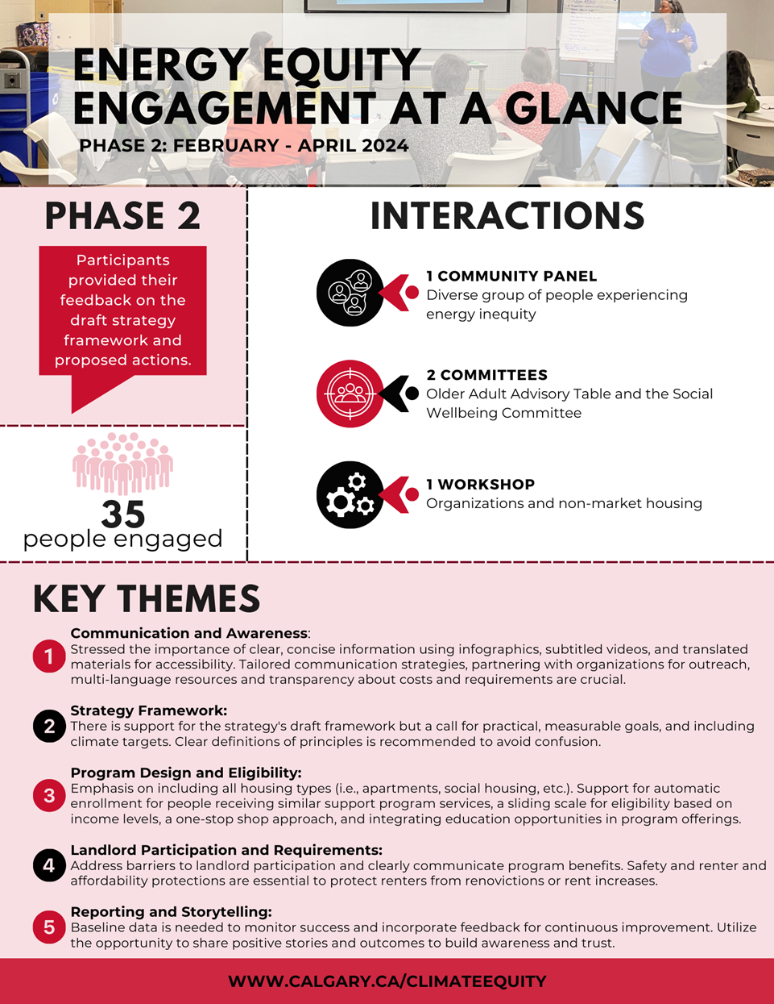

Appendix B: Participant Engagement Feedback
At the end of every engagement session, we asked for feedback on whether the engagement was meaningful to better understand how to modify for future sessions.
The feedback we received is summarized below.
Community Advisory Panel #3: July 30, 2024
Total Responses: 10
Question | Strongly Agree | Agree | Disagree | Strongly Disagree
We were clear in what we were trying to do for the meeting. | 9 | 1 | 0 | 0
The information we talked about was understandable. | 9 | 1 | 0 | 0
Everyone’s ideas were welcome. | 9 | 1 | 0 | 0
You feel that you were able to participate in a meaningful way. | 10 | 0 | 0 | 0

Please tell us anything else we should consider for the next meeting.
Response 1 | It very well implemented. Absolutely needed.
Response 2 | I need to XXX to review more & would like to share with senior groups in my community. How to engage community groups.
Response 3 | Have an online option to attend.
Response 4 | I would like to have the opportunity to participate in some others projects. Also, I would like to be invited for next meetings of the final step Strategy.
Response 5 | Thank you for hearing the thoughts and suggestion. Being kind and polite. As well keeping in mind the time. As well thank you for providing the refreshments.
Response 6 | Thank you for this knowledge building experience, I learned a great deal.
Response 7 | Consider how to get landlords to care about the program.
Response 8 | Thank you for all the effort
Response 9 | I would love to talk more if we have a session about clean energy solution and application of technology.

