
What We Heard Report

Access Design Standards Update: Round 2B
Technical Feedback Engagement

April 6, 2026
Land acknowledgement
The city of Calgary sits on fertile land where two rivers meet, where Indigenous Peoples have been gathering for thousands of years, sharing knowledge and storytelling, and planning for future generations. The traditional names for this place we know as Calgary are Moh-kins-tsis, Wîchispa Oyade, Otos-kwunee and Guts-ists’i - the land that has given so much to so many. Calgary is located on the traditional territories of the people of the Treaty 7 region in Southern Alberta. This includes the Blackfoot Confederacy, made up of the Siksika, Piikani, and Kainai First Nations; the Îethka Nakoda Wîcastabi First Nations, comprised of the Chiniki, Bearspaw, and Wesley First Nations; and the Tsuut’ina First Nation. Calgary is also homeland to the historic Northwest Métis and to Métis Nation of Alberta, Region 3. We acknowledge all Indigenous urban Calgarians who have made this city their home. Together, their spiritual and practical relationships to the land create rich lessons for our life as a community.
About this document
To ensure this document is easy for everyone to read, we used accessible formatting aligned with the City of Calgary’s communication standards. The document features a user-friendly layout with readable sans serif fonts, plain language, and a navigation pane with clear, structured headings. We kept the use of graphics and tables to a minimum, and when they are included, added alternative text. These choices help make the document accessible to all readers, including those who use assistive technologies.

Executive Summary: Round 2B Technical Feedback
The City of Calgary is updating its Access Design Standards (ADS) with the aim to enhance accessibility across all City-owned infrastructure. These standards are intended to ensure accessibly designed environments for people with physical, sensory, and cognitive disabilities. Engagement on the Access Design Standards Update is an important step in ensuring the standards reflect the accessibility needs of its users.
Engagement purpose
Following engagement with members of the disability community in Round 2A, the project team analyzed the feedback and developed a draft ADS. Round 2A was conducted in the Spring of 2025 and focused on understanding experiences with the built environment from individuals with lived experience within the disability community. Round 2B is a continuation of the targeted engagement from Round 2A but with the focus on understanding the perspectives of industry experts with the technical expertise to review the draft ADS for clarity, feasibility and compliance with existing codes.
Engagement tactics
Tactics for Round 2B involved the online engagement portal where participants were able to download and review the entire draft ADS and provide their comments via a supplementary feedback form. The project team also hosted information sessions for any interested parties to learn about the key proposed revisions and to ask questions to supplement their review. Accessibility accommodations were also provided upon request.
What we heard: key themes
Overall, participants placed significant importance on ensuring the Access Design Standards were aligned with other standards, codes, and bylaws applicable to The City of Calgary such as the Street Manual and City of Calgary Standard Specifications - Road Construction and the Calgary Parks and Open Spaces – Development Guidelines and Standard Specifications: Landscape Construction. Participants recurringly asked for further clarification of technical requirements, the addition of illustrations to help understand concepts, and clearer explanations around the intent of the standards. There were also recommendations to have a more consistent formatting approach throughout the document including consistent and accurate spelling and grammar. Some of the themes that emerged for sections in the draft were as follows:
- Vehicular access: Ensure alignment with other existing bylaws and City standards for accessible parking, curb ramps, drop‑off zones, and signage requirements, along with clearer explanations of intent behind requirements and more illustrations of concepts.
- Pedestrian crossings and signals: Provide more detail on when and how features such as pedestrian signals, raised crossings, and tactile indicators should be applied while considering site-specific design and maintenance constraints.
- Exterior areas and features: Make the requirements for accessible play spaces more inclusive, provide more technical detail for service dog relief areas, outdoor seating, and outdoor patios and refine language and consistency within clauses.
- Ramps, stairs, elevators, and lifts: Distinguish between the requirements for exterior stairs associated with buildings and steps in landscaped areas and trails, provide a formula for colour contrast, and provide more coordinated guidance on product selection and application for tactile indicators across City departments.
- Sanitary facilities: Revise requirements related to the placement of toilet fixtures (e.g. soap dispenser, dryer) in washrooms to include mounting heights, allow for flexible placement when space is limited, and improve universal washroom occupancy indicators and emergency features, adding clearer illustrations for accessible showers.

Table of Contents
Executive Summary: Round 2B Technical Feedback 3
1.0 Project background 6
2.0 Engagement overview 6
2.1 Audience 7
2.2 Tactics 8
2.3 Timeline 9
3.0 What we heard 10
3.1 What we asked 10
3.2 General comments on the draft ADS 11
3.3 Section A: Accessible spatial planning 12
3.4 Section B: Vehicular access 12
3.5 Section C: Pedestrian crossings and signals 13
3.6 Section D: Exterior paths of travel 14
3.7 Section E: Exterior areas and features 16
3.8 Section F: Entrances, exits, doors and doorways 17
3.9 Section G: Ramps, stairs, elevators, and lifts 17
3.10 Section H: Interior circulation 20
3.11 Section I: Interior rooms and services 21
3.12 Section J: Interior features 22
3.13 Section K: Sanitary facilities 22
3.14 Section L: Signage and wayfinding 24
3.15 Section M: Recreation facilities 24
3.16 Section N: Calgary transit facilities 24
4.0 Conclusion and next steps 24
Appendix A: Verbatim comments 26

1.0 Project background
The City of Calgary (the City) is updating its Access Design Standards (ADS), a policy document that guides project managers and external consultants on design and construction requirements for capital project for new builds or renovations of existing infrastructure.
The City is committed to removing barriers that prevent people with disabilities from fully participating in employment and in all City programs and services. The ADS outline the City’s requirements for designing accessible infrastructure. These standards apply to new and renovated City-built infrastructure including buildings, sidewalks, parks, transit facilities, and more, as well as to City-leased facilities, and any facilities located on City-owned land. The standards enhance accessibility by mandating design measures that exceed the National Building Code – 2023 Edition. This update supports greater alignment with national and international best practices and helps ensure City spaces are accessible to people of all abilities.

2.0 Engagement overview
Engagement on the Access Design Standards Update is an important step in ensuring the standards reflect the accessibility needs of its users. In previous rounds of engagement (Round 1 and Round 2A), the project team focused on understanding experiences with accessibility, including needs and challenges from groups with lived experience and subject matter experts in Calgary’s disability community. The goal of these rounds was to learn more about people’s priorities and day-to-day experiences, so that the updated Access Design Standards (ADS) better reflect what the community needs. Engagement activities included in-person workshops, online participation, and meetings with City of Calgary committees. To read the What We Heard Reports from Round 1 and Round 2A visit https://engage.calgary.ca/ADSU.

The project team reviewed and analyzed all participant feedback from Round 1 and Round 2A and used these insights to update the draft Access Design Standards. These revisions were directly informed by lived experience and ensure that the draft standards reflected the accessibility needs of its end users and reflect community priorities.
Round 2B: Technical Feedback
Before finalizing these updates, it was important to ensure the proposed updates to the draft ADS were technically sound, feasible and aligned with current codes and construction considerations. Round 2B is a continuation of the targeted engagement from Round 2A but with the focus on collecting feedback on the technical elements of the draft ADS including the accuracy, clarity, feasibility and compliance with existing codes. The technical review of the draft standards in Round 2B ensures the draft ADS not only reflects the perspectives of the individuals that are the most impacted by them but also ensures they are technically feasible and can be implemented by the parties responsible for building and maintaining these standards.

2.1 Audience
The impacted and interested parties for Round 2B were professionals who had the technical expertise to review the draft and evaluate it for accuracy, clarity, feasibility, and compliance with legal and regulatory requirements and included architects, landscape architects, engineers, designers, developers etc. The project team invited the following organizations as well any of their members and participating organizations to provide feedback to the engagement:

- Access Design Standards Technical Subcommittee, Advisory Committee of Accessibility, City of Calgary
- Building Industry and Land Development Association – Calgary Region
- Alberta Association of Landscape Architects
- Alberta Professional Planning Institute
- Consulting Architects of Alberta
- Consulting Engineers of Alberta
- Interior Designers of Alberta
- Calgary Construction Association
- Alberta Roadbuilders and Heavy Construction Association

2.2 Tactics
During Round 2B, the impacted and interested parties identified above were notified of the launch of the Round 2B of engagement through email to the respective organization’s representatives. Organization representatives were then asked to distribute information about the engagement to their members. Interested participants were invited to download and review the draft ADS (available on the Engage portal) in its entirety and provide feedback by uploading their comments via a supplementary feedback form on the same Engage portal page or by sending their feedback through email. Accommodations were provided upon request including time extensions for providing feedback.
Engage portal page address: https://engage.calgary.ca/adsu/technicalfeedback.
The use of an online platform provided the most flexibility and ease of review given the technical nature of the feedback required for this document as well as the length of the draft ADS which totalled 157 pages.
Additionally, three open-invite virtual information sessions were held in November of 2025. In these sessions, the project team presented the key proposed changes to the draft ADS, provided an opportunity for interested parties to ask questions about the proposed changes, and provided information on how participants could provide feedback. Upon request, the project team also held additional follow-up sessions with participants and organizations to help further clarify any questions and collect feedback.
The engagement period ran from November 3, 2025, to November 25, 2025, during which the submission tool was open on the Engage portal page. However, accommodations were made to extend the deadline for providing feedback until January 15, 2026, upon request.
Session date | Session type | Est. attendance
Wednesday, November 5, 2025 | Information session: Access Design Sub-Committee | 11
Friday, November 7, 2025 | Information session: All interested | 22
Tuesday, November 18, 2025 | Information session: All interested | 17
Wednesday, November 19, 2025 | Information session: Access Design Sub-Committee (individual request) | 1
Friday, December 5, 2025 | Follow-up session 1: BILD Calgary  (organization request) | 42
Thursday, January 15, 2026 | Follow-up session 2: BILD Calgary  (organization request) | 9
Total |  | 102
A total of seven submissions were received with comments on the ADS Draft with some of the submissions including comments on behalf of multiple organizations.

2.3 Timeline
The timeline for engagement rounds and tactics for this project is as follows:
November 2024 – January 2025
Round 1: General outreach and engagement
- Conduct outreach and engagement activities within Calgary’s disability community.

March – May 2025
Round 2A: Lived experience outreach and engagement
- Focus on key sections and engage specific groups with lived experience and subject matter experts within Calgary’s disability community.

November 2024 – January 2026
Round 2B: Industry outreach and engagement
- Meet with industry and technical experts to build on the feedback from Round 1 and 2A.

Spring 2026
Round 3: Report back and finalization
- The What We Heard Report for Round 2B is published and draft ADS moves forward for approvals.

3.0 What we heard

The key themes and considerations from feedback provided by participants according to sections within the draft ADS are summarized below. For verbatim comments please see Appendix A: Verbatim comments. The Calgary Draft Access Design Standards document that was distributed to participants of this round can also be found on The City of Calgary Engage portal at https://engage.calgary.ca/ADSU/technicalfeedback.
Note: This feedback is not statistically representative of all Calgarians, and therefore in this report, people who provided feedback will be referred to as participants or respondents and not Calgarians.

3.1 What we asked
Participants were asked to review the draft ADS and provide technical feedback on the standards. Technical feedback referred to structured, evidence-based input that is aimed at ensuring accuracy, clarity, feasibility, and compliance with legal and regulatory requirements. Feedback could also include but was not limited to:
- limitations related to products, supplies, or construction methods (e.g., unavailable sizes, structural impossibilities),
- identification of gaps or inconsistencies,
- recommendations for improvement based on accessibility best practices and relevant legislation,
- evaluation of technical feasibility, and
- clarification of terminology or formatting to ensure the standards are easily understood and actionable.

3.2 General comments on the draft ADS
Overall, participants placed significant value on ensuring the ADS is aligned with other existing standards and guidelines. They asked for information on standards employed by other accessibility organizations or municipalities within Canada, more detailed explanations on how certain standards align with other referenced documents, and on any areas of non-compliance with other guidelines, if they exist. The current City standards, policies and bylaws most frequently referenced in feedback include the:

- City of Calgary Standard Specifications - Road Construction
- Calgary Parks and Open Spaces – Development Guidelines and Standard Specifications: Landscape Construction
- City of Calgary Street Manual
- Calgary Land Use Bylaw
- National Building Code – Alberta Edition
- Temporary Traffic Planning (TCP)
- The Alberta Highway and Rules of the Road Regulation 304/2002
- Accessible design for the built environment (CSA B651- 23)
- Assistive products for blind and vision-impaired persons – tactile walking surface indicators (ISO 23599:2019)
- Building Construction — Accessibility and usability of the built environment (ISO 21542:2021)

There was also an emphasis on the importance of clearly explaining the intent behind standards so that they can be consistently applied in various public infrastructure settings and clearly explaining the process for review, consultation and approval of the ADS. Participants also highlighted a need for greater consistency within the formatting of the document itself, particularly the layout of section components such as the explanations, scenarios, illustrations, etc.
There were multiple recommendations to consistently use Canadian English spelling instead of American English throughout the document, with the most common critique being the use of color instead of colour. There was also a desire to have clearer definitions of accessibility-related terms, particularly for the words accessible, barrier-free, and inclusive so that the intent behind a standard is clear, and for the use of these terms to be consistent throughout the document.

3.3 Section A: Accessible spatial planning
Participants noted the need for consistency in measurement for turning circles, highlighting that the same measurement for the turning circle radius, should be maintained through the remainder of the document. In the draft document, there were different turning circle radii if other clearance spacing was acceptable. In reference to illustrations depicting various spatial clearances, participants requested additional illustrations for other scenarios like for a person with a service dog, a child with an adult, or people with other diverse cognitive abilities if applicable, and to add requirements for sight elevations.

3.4 Section B: Vehicular access
Designated accessible parking stalls: Participants emphasized that many of the dimensions for accessible parking stalls are supported by the guidelines within the Land Use Bylaw and recommend including those references within the ADS. Where the dimensions do deviate, such as the 2600 mm stall width requirement in the draft ADS versus the 2400 mm stall width requirement in the Alberta Building Code, participants suggest providing an explanation for the deviance.
Referring to the requirement that a curb ramp be installed within an access aisle when there is an accessible parking stall next to a sidewalk, participants requested more detailed illustrations of curb ramps including the various types and their accessibility applications. Comments specifically note that curb ramps are currently only required when there is a grade change between sidewalks and parking stalls, and flag that detail on wheelchair ramps is not provided. Curb ramps and on-street parking stalls are also approved according to the TCP and City Road Specifications, so participants emphasize the need to ensure alignment within these City standards for parking stalls.
Passenger drop-off and pick-up zones: Participants wanted more information on where the requirements for these zones apply, for example whether they apply to non-City owned buildings and asked for examples of the types of infrastructure (e.g. event centres, LRT stations, arenas, etc.) that need to have these zones. This was followed by requests to provide more illustrations with technical details on various configurations of pick-up and drop-off zones.
When referring to parking signage, participants suggested the following:
- adding a requirement to provide signage for virtual payment information to keep up to date with modern methods.
- referring to other traffic standards for road marking materials.
- adding guidance for vertically mounted signage to avoiding impeding mobility in paths of travel.
Finally, participants notably highlighted the need for clearer explanations behind the intent of requirements and requested more detail be given on the performance expectations rather than specifying details that may limit application. For example, instead of saying that an accessible parking stall should be paved on a concrete hard surface, say instead that it should have a stable, firm, and slip-resistant surface.

3.5 Section C: Pedestrian crossings and signals
Accessible Pedestrian Signals: Participants identified several issues including:
- whether the standard to include signals at all new signalized intersections for pedestrians will be communicated to industry developers and City departments.
- the placement of push buttons and signal poles being a concern due to constraints in where these features can naturally be placed, and because they may unintentionally hinder accessibility by having push buttons out of reach; participants also suggest providing illustrations with descriptions for more guidance.
- confusion about what tactile directional arrows are when referring to the requirement to have these arrows near push buttons at crosswalks.
Raised pedestrian crossings: Participants primarily wanted more clarity on technical details such as when raised crossings are required, how wide a raised crossing should be, what is considered a safe crossing point and how crossings need to be marked for tactile users. Suggested revisions were to distinguish between fully raised and partially raised crossings and have a better introduction to this section.
Curb ramps: Participants also identified areas where the standards may conflict with construction realities including:
- the requirement to have curb ramps align with the direction of travel is not always possible due to curb geometry, maintaining vehicle movement and design safety.
- the requirement to have drainage prevent water and snow build up at the bottom of ramps because preventing accumulation is also tied to snow maintenance which is an operational element.
Suggested revisions to the clauses include adding catch basins behind curb ramps and aligning the dimensions provided for a level surface on a sidewalk behind a curb ramp with the City of Calgary Standard Specifications - Road Construction. Other notable comments include maintaining separation between bike and pedestrian pathways and crossings because people who use canes can’t detect mixing zones or shared crossings and need clear, tactile cues like curbs and steeper slopes.

3.6 Section D: Exterior paths of travel
Exterior accessible path of travel: Participants primarily asked for more descriptive and quantifiable explanations of terms. Specifically, comments asked to describe the following terms: level or gently sloped, well-drained, firm, stable, and non-slip surfaces which were descriptors for designing paths of travel in the draft ADS. Participants also wanted to understand more about paths of travel that go behind a loading or garbage pick-up area and suggested adding an illustration for what setting this is describing and explaining why back lanes were mentioned as an exception to this standard.
Obstructions and clearance: In reference to the requirement to keep pathways clear of obstructions, participants recommended adding light poles and traffic signal poles to the list of obstructions. Participants want to see more details in explanations for items that may need to be placed adjacent to or along paths of travel due to site constraints including manhole covers, bollards and posts. Comments also highlighted discrepancies in Figure 15.1 Grate Opening Width – the figure shows the grate opening as parallel rather than perpendicular as is the requirement.
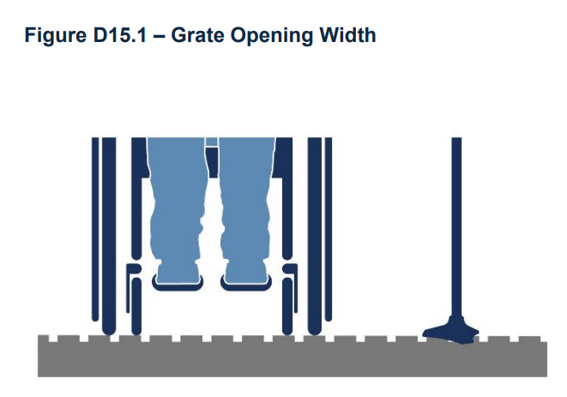

Parks and trails: Participants overall recommend revising the clauses in this section to clarify the intent of inclusive access without implying that every amenity or experience must be available to every person, which is neither practical nor desirable when designing for a diverse range of experiences, abilities, and preferences. They also asked for more detail on dimensions for park and trail signage and to clarify whether these signage requirements are applicable outside of parks.
Overall, participants asked for descriptions of terms used in this section including colour contrast, slip resistant, and pathways, including definitions of regional and local pathways, and recommended revising language to consider site-specific and context-specific variability while clarifying intent.

3.7 Section E: Exterior areas and features
Accessible play spaces: Participants recommended the clauses related to accessible play spaces be more inclusive. Suggestions include recognizing not just parents but also caregivers, families, and friends in explanations and integrating requirements around the inclusivity of these spaces, especially for people with cognitive disabilities. Similarly, there were also requests to clearly define descriptors such as accessible, inclusive, and provide more examples of accessible playground equipment.
Service dog relief areas: Participants were confused on whether these requirements apply to exterior areas only or to both exterior and interior relief areas in high‑use buildings and asked for more clarification. They also flagged sand, which was preferred surface for relief areas in the draft, as one that would not meet the criteria for firm and slip resistant.
Outdoor tables and seating areas: Participants wanted more explanation on where seating should be places along pathways and particularly on why seating was required at 30 metre intervals along pathways, referring to other standards that recommend 50 metres. They also noted that clauses had contradicting statements for whether armrests and back support were necessary for all seating. Participants also highlighted that requiring colour contrast for seating areas may limit product choice. For example, wood seating, which is frequently used, may not meet the criteria for colour contrast according to the ADS. They recommended further reviewing material and product applications in this context.
Outdoor patios and balconies: Participants primarily identified confusing language within the clauses such as duplicate standards and inaccurate references to other codes. One comment also highlighted that percentage requirements for accessibility, such as the requirement to have 20% of seating be accessible, should be rectified to say a “minimum of 20%.”
Other general comments expressed a desire for more clear definitions for the following terms: accessible, inclusive, transition point, and outdoor patio. Some recommended refining the clauses so that language like, “Service dog relief areas should be accessible…” in the draft ADS, is made into a formal clause rather than used in introductory text. More information on colour contrast as well as a list of approved surfaces for different areas were also requested.

3.8 Section F: Entrances, exits, doors and doorways
Entry seating: Participants requested more details on how far a seat can be located from the entrance of a building that has a passenger pick-up and drop-off area – noting that in some locations, buildings can be situated against a property line or loading zone causing spatial constraints. Participants requested additional detail on where a seat could be realistically placed in situations with limited space. In reference to the direction to provide signage for building main entrances that cannot be easily found, participants also requested more clarification on what constitutes a building entrance that is not easily identifiable and how much additional signage needs to be present.
Doors and doorways: Comments on doors and doorways in this section were primarily requesting clearer explanations and visuals for door layouts. The language used to describe power doors was confusing and more detail is needed for each type of door and its application, along with diagrams and references to any existing codes (e.g., codes for color contrast) to support understanding. Comments specifically noted awkward phrasing in the language used to explain why power operated doors are important, inconsistencies in the requirement for glazed doors between this section and Section H: Interior circulation, as well as minor spelling errors such as writing powder door instead of power door.

3.9 Section G: Ramps, stairs, elevators, and lifts
Exterior stairs: Participants requested clarification on whether the technical requirements for exterior stairs apply for stairways of buildings, or whether they also extend to landscape “steps” commonly used in parks, plazas, and other public amenity settings. They note that steps can be designed through an accessibility lens but may not meet the same requirements as built-up stairs. The feedback highlights a need to clearly distinguish and define a stair versus a step and the requirements for each. Participants also requested a formula for colour contrast be provided where it is required, such as in the requirement for a 50% minimum colour contrast between a stair tread and riser.
Section figures: Participants highlighted issues with the below illustrative figures:
- Figure G4 showed Ramp Configurations and Landing Size but the slope percentages were not shown and there is a desire to see a slope percentage for each scenario illustration in this figure.
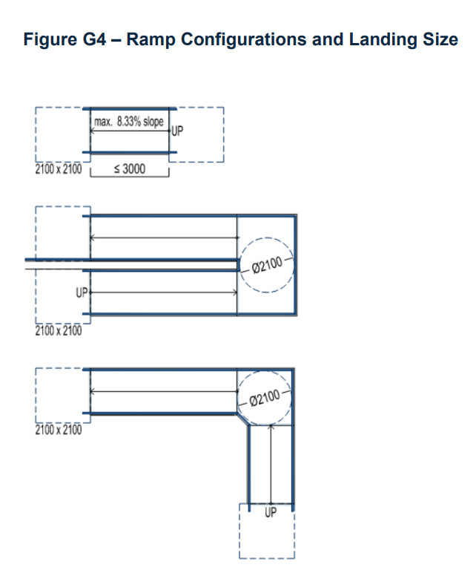

- Figure G19 showed Handrail Extensions & Attention (tactile walking surface indicators) TWSI, however, Clause G19 in the draft ADS referred to colour contrasted cane-detectable barriers and cantilevered staircases, which appears to be a discrepancy between the two.
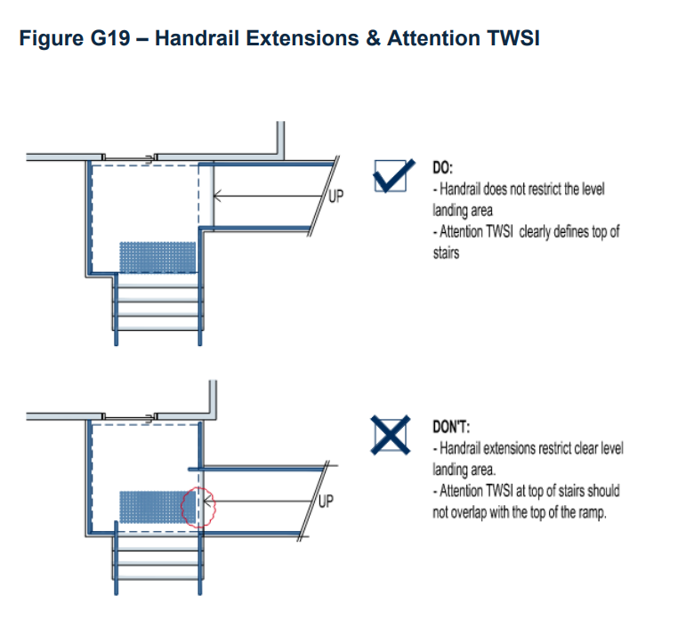
- Figure G25 showed Examples of Handrail Termination to Post, Wall, and Floor but participants want to see additional detail where the path of travel runs relative to the rail extension.
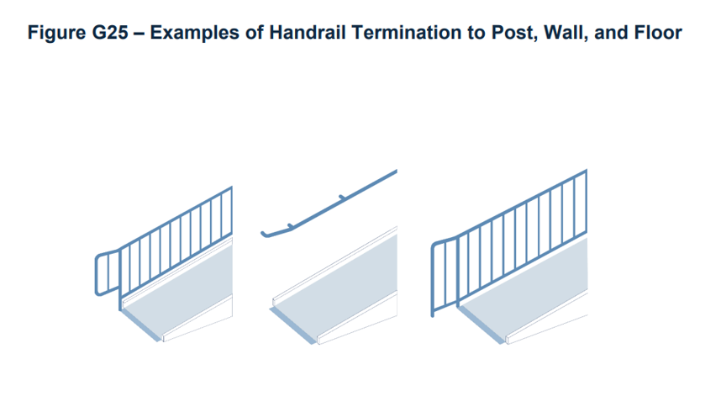
Additionally, there is a desire for more detail on the required standards for the materials, colour, and dimensions that should be applied for exterior tactile warning plates installed in wheelchair ramps or at curb edges. Participants note there is currently a lack of guidance from The City of Calgary on the approach for product selection and application (e.g., when to use a cast iron tactile plates verses a plastic yellow plate) and want to see some consistent guidance between City departments on this topic.
Finally, minor spelling and grammatical errors were identified and need to be rectified, including incomplete sentences (e.g. “…sentence ends with ‘and’ but nothing follows”) duplicated explanations for requirements, and the lack of Canadian spelling (e.g., using multi-story instead of Canadian English multi-storey).

3.10 Section H: Interior circulation
Participants primarily highlighted discrepancies in figures in this section:
- There are two figures labeled as H4, H4 – Protruding Objects and H4 – Flooring Surfaces, resulting in duplicate numbering.
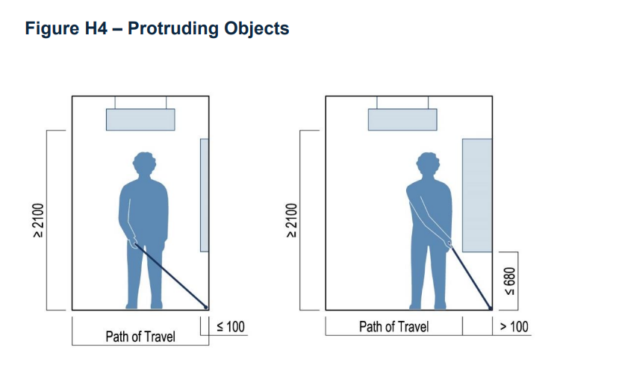
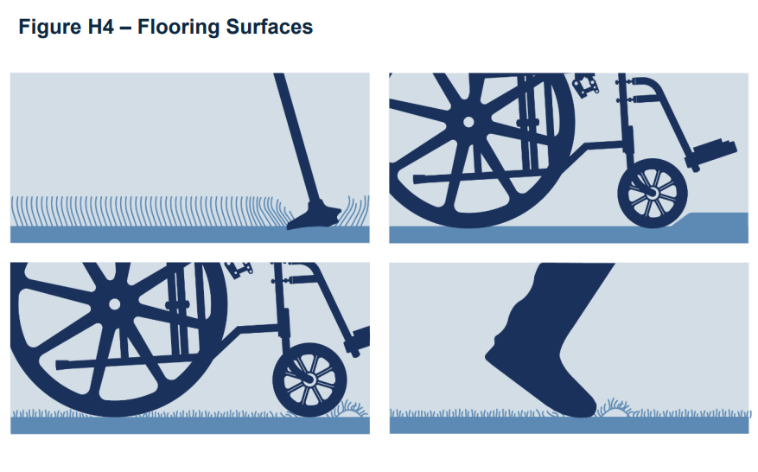
- Figure H5 – Beveled Floor Transitions Between Different Flooring does not appear to refer to any of the clauses in the section and requires further clarification.
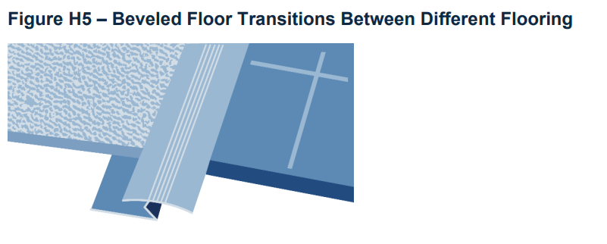

3.11 Section I: Interior rooms and services
Mobility device storage areas: In reference to the requirement that each storage space within a mobility device storage area needs to have a clear floor area of at least 900 mm by 1500 mm, participants noted that not all mobility devices require the same storage space as a wheelchair and therefore that not every storage space may need to meet that requirement. They propose that the requirement be revised so that at least one mobility device storage space meets the 900 mm by 1500 mm clear floor area requirement, while allowing flexibility for other storage space dimensions within the mobility device storage area. One grammatical error was also highlighted where the phrase mobility storage area was used when it should say mobility device storage area.
Participants also recommend the following revisions:
- Meeting rooms: In reference to the requirement that tables should not be used on raised platforms because they present barriers to access for people with mobility challenges, participants proposed the requirement also apply to chairs as well – so neither tables nor chairs should be used on raised platforms.
- Exhibit and display spaces: In reference to the requirement that table displays need to be located between 1100 mm and 1200 mm above the floor or ground level, participants noted that this range is not aligned with other accessibility standards including the CSA B651-18, the ISO 21542:202, and the ISO 23599:2019. Participants recommended that the range be revised to 740–860 mm to align with the other standards.
- Assembly Areas: In reference to the requirement that lighting strips need to be provided on steps and accessible paths of travel, participants said that some areas such as arenas and other public buildings may have adequate lighting on paths of travel already and therefore do not require lighting strips. Participants recommended the requirement be revised so that lighting strips be used in areas where there is inadequate lighting.

3.12 Section J: Interior features
Participants specifically wanted greater clarification on where water-bottle filling stations need to be located, for example whether they need to be located on each storey or level of a building.

3.13 Section K: Sanitary facilities
Toilet Fixtures: Participants asked for more clarity and detail on specific requirements for toilet fixtures including the height from the floor that fixtures need to be mounted, as well as recommended that sanitary napkin disposal bins be placed next to every toilet regardless of the gender the washroom is designated for. There were also some concerns that there would not be enough space to include all mounting fixtures (soap and paper towel dispensers, sharps disposal container, shelf, coat hook, hand sanitizer, dryer) next to the sink and recommended clarifying whether these fixtures can be placed elsewhere.
Universal washrooms: Participants primarily commented on occupancy indicators in universal washrooms. Specifically, they want to emphasize that indicators should clearly communicate when a washroom is in use and recommended removing the 15-minute time recommendation for the indicator to be left on once activated – instead the indicator should be on for the entire time of use.
Additional comments recommended considering locks that can be released from the outside for accessible shower stalls in case of emergencies as well as adding an illustration of an accessible shower stall as a visual support for what they should look like. Finally, participants identified a figure that had no heading or figure number assigned to it, which needs to be addressed for understanding of the requirements.
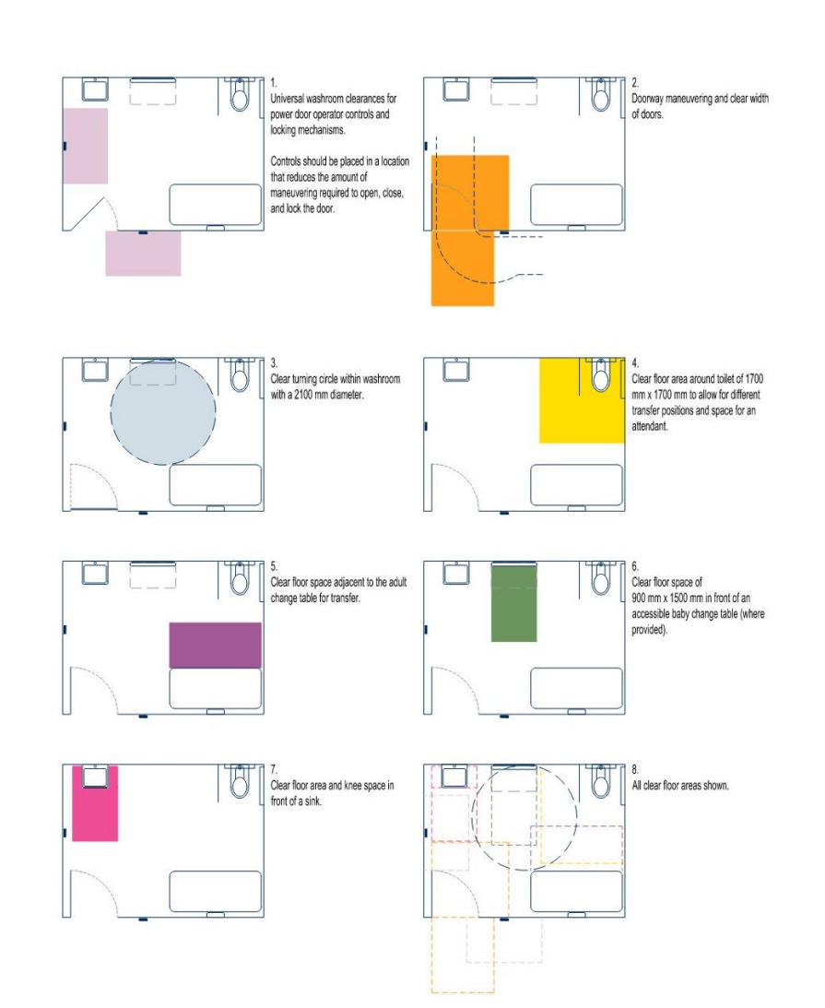

3.14 Section L: Signage and wayfinding
Overall, participants wanted to confirm that the signage standards within the draft ADS are in alignment with national organization standards including the ISO 7001, which outlines the international standards for public information symbols.

3.15 Section M: Recreation facilities
Exercise and fitness areas: In reference to the requirement that raised stretching mats be available as an alternative to stretching on the floor, participants wanted more detail on minimum overall size of the stretching mat that needs to be provided. One comment highlighted a spelling error where the word shall was used instead of shallow in the All-Pools Basin clause.

3.16 Section N: Calgary transit facilities
Participants specifically asked for more clarification on the requirements for transit shelters at bus stops and on who has the responsibility for the installation of transit shelters (i.e. whether it is Calgary Transit or another party).

4.0 Conclusion and next steps

Feedback from Round 1 and Round 2A was used to draft the proposed updates to the Access Design Standards, ensuring that the update to this document considers the lived experience of members of the disability community.
Round 2B then focused on engaging with industry and technical experts to understand whether the proposed revisions and the draft ADS in its entirety had gaps or inconsistencies and if the standards were clear, technically feasible, and robust.
The feedback from Round 2B primarily focused on the need to provide more explanation behind the intent of the standards to allow for consistent application of requirements and ensure intent-driven outcomes for accessibility. Participants requested more detail where necessary, outlined any concerns that may arise due to site-specific context or variability, and overall emphasized the need to align with other existing codes and standards applicable to The City of Calgary.
Together, these two perspectives ensure the final standards are both user‑informed and technically achievable, resulting in updates that are meaningful, implementable, and effective so that the standards can work in principle as well as in practice.
The project team will integrate community, industry, and technical insights into a complete final version of the Access Design Standards that will move forward for approvals in spring of 2026.

Appendix A: Verbatim comments
Verbatim comments and quotes, including all feedback, suggestions, comments and messages that were collected online and in-person through the engagement, were presented in their entirety in this verbatim report. All input has been reviewed and provided to Project Teams to be considered in decision making for the project.
Any personal identifying information has been removed from the verbatim comments presented here. Comments or portions of comments that contain profanity, or that are not in compliance with The City's Respectful Workplace Policy or Online Tool Moderation Practice, have also been removed from participant submissions.
Wherever possible the remainder of the submissions remains. No other edits to the feedback have been made, and the verbatim comments are as received. As a result, some of the content in this verbatim record may still be considered offensive or distasteful to some readers.
Section | Detail | Feedback | Proposed Revision
General | General | Use Canadian spelling. | "colour" (not "color")
General | General | Consistent use of "accessible", "barrier-free" and "inclusive", in alignment with provided definitions. | For many of the exterior standards, "accessible" is the term used, however in most cases "barrier-free" is the intent.
General | General | Avoid use of terms which are open to interpretation and/or are context-dependent. Greater specifity, if appropriate OR include as intent or recommendation, not requirement. | eg: Minimal
General | General | Avoid providing very specific dimensional information where a range would be more appropriate for meeting the intent, unless there is an established/accepted standard that the ADS are aligning with (and then provide the reference)
General | General | Highlight the review/approval and consultation process so it is clear and consistently applied.
General | General | Appreciate the additional "elements" that are used to explain intent, etc. however, there are too many kinds of elements, and they are not consistently applied throughout the document.  Recommend clause specific elements - explanations, notes, scenarios, exceptions. Differentiate/separate these within the clauses.  (graphic examples can be useful to illustrate scenarios and/or best practices)  Include references and best practices as part of the broader sections, and include references notes as needed. This will also avoid duplication. | B1  Explanation: This design increases the safety of all parking facility users including people who use wheeled or other mobility devices including canes, crutches, braces, and artificial limbs.  Scenarios: One way to achieve this is to have the accessible parking stalls located adjacent to the 'building side' of the parking lot with a walkway that leads directly to the accessible entrance to eliminate the need to cross any parking drive aisles.
General | General | For 'Referenced Documents", include brief notes about what they were references for. | This could be provided as a matrix of information, including links, if available, for the reference material.
General | Tactile Attention Indicators | Tactile Attention Indicators  Because these are references throughout, suggest including earlier.  "… distinct underfoot textures." - "… distinct, detectable textures."  Provide an inventory of types and appropriate applications.
General |  | There is value in establishing a consistent form of applying accessibility standards for new infrastructure. This should allow consistency in application, material use, predictability, etc.
General |  | What recognition has the CofC achieved with national bodies in this field? And with formal publications like the National Building Code?
General |  | Are there instances where the CofC know that they are non-compliant or suggesting alternate products or applications when compared to other Accessbility Groups in Canada?
General |  | Does the Advisory Committee on Accessbility have national recognition? Or some form of Professional recognition? (question applies to its subsidiaries as well)
General |  | Has ADS identified similar organizations in Canada that have produced similar products to this technical document? If so, what are they? And why is this standard not being issued in collaboration with those organications?
General |  | This document should consider being organized by location or form of public infrastructure. For example, should sections be identified by that applicable to Public Road Rights-Of-Ways, Public Municipal Reserves, Public Buildings, etc? This could encourage cleaner collaboration between other City issued design specifications and documents.
General |  | Spelling of numerous words are incorrect (American rather than Canadian English). For example, metre (including diameter) and colour. Note, some sections are correct.
General |  | Provide a formula (e.g. WCAG or Weber) and value (e.g. ratio or percentage) to the colour contrast. Many specifications require colour contrast but does not provide a quantifiable metric. An overarching value and formula for all specifications, unless otherwise noted, would provide support designers and building inspectors to ensure consistency and compliance.
General |  | Has the project team considered making external standards generic as to ensure continued accuracy in between ADS updates? For example:  a. Multiple sections: The Street Manual, notably that it is not yet released and delayed (may impact release of the ADS).  b. D18: Details in the Landscape DGSS
General |  | Bikes should remain on-street wherever possible. Having a MUP beside a sidewalk with no barrier/curb to act as detectable delineation is of no value to a cane user.
General |  | A cane user cannot tell if there is a mixing zone or not, where it is/extends/starts/ends or how it is to function for other users, so it is of little value.
General |  | The WCR slope is important at >6%, same with the cross-slope on a sidewalk extending to the curb. These features are detectable under foot and are generally expected by cane users.
General |  | for MUP/raised cycletrack alignment: Place ramps and intersection crossings in straight lines with how the paths are aligned exiting and approaching any mixing zone. Especially for winter, with how snow removal is done, a cyclist will ignore any mixing zone and follow the clearest path and with any windrows.  a. The bike crossing distance at intersections is different than any pedestrian requirement, so shared crosswalk and Elephant Feet crossings should be discouraged/avoided.  b. A cane user cannot tell if there are Elephant’s Feet or if there is a shared crossing. All they sense is that a cyclist is somehow present, which is a safety concern for them, so the users should be separated at crossings.
General | Various item numbers starting at B10 | Use Canadian spelling throughout (i.e. colour vs. color) | Explanation: Colour contrasted parking payment machines help ensure that everyone can pay for parking easily and conveniently.
A1, Accessible Spatial Planning | A1, | The 2100mm turning circle  This is a logic question: If the 2100mm dimension is what it is, why can’t that measurement follow-through and proliferate in the rest of the narratives and we only see “one” minimum?
General, Accessible Space Planning | A4 | Spatial Planning additions. | Add person with service dog. Add child with adult.  Other helpful standards include sight elevations.  Are there spatial standards available for those with diverse cognitive abilities?
Compliance and Regulatory Requirements  Vehicular Access | A  B | The Alberta Highway and Rules of the, Road Regulation, 304/2002 should also be referenced as it is the preeminent document for operations in the public right of way.  Include reference that this document is also in-play for Mobility when they are involved.
Vehicular Access | B4 | Comment is general - Expansion joints are required on exterior concrete walks per City Road Specifications. | Please be more specific - remove "minimal" and include maximum joint depth/width or defer to the City of Calgary Roads Specifications.
Vehicular Access | B4 | General, with specific example.  Avoid specifying or prescribing materials. Focus on the intent and performance requirements. | eg: instead of:  Designated accessible parking stalls and the adjacent access aisle shall be paved or concrete hard surface.  try:  Designated accessible parking stalls and the adjacent access aisle shall have a stable, firm, and slip-resistant surface.
Designated Accessible Parking Spaces, | B5 | “…a ramp shall be installed…” Mobility (TCP) approves on-street accessible parking according to an established policy/practice. Current policy is that these on-street spaces are registered with the adjacent parcel, and preferably a residential parcel as the sign installation policy needs to connect to the handicap placard and mailing address.  There several thousand disabled sign installations, so if it is a 100% requirement to have a ramp in these locations, what is the funding source, timing and obligation associated with these installations? Right now the DZ sign installation is free-of-charge to the applicant and a ramp represents several thousand dollars in new assets.
Vehicular Access | B5 | Wheel Chair Ramp detail not provided | Ensure it fits the sidewalk dimensions and is in alignment with the detail provided in the City Road Specifications
Vehicular Access | B6 | The dimensions of parking stalls (2,600mm) aligns with the Part 3, Division 6, Section 122 (1) of the Land Use Bylaw. | Consider the need to include in the ADS.
Vehicular Access | B6 | Part 3, Division 6, Section 122 (13) of the Land Use Bylaw defines the maximum slope for parking stalls. | Consider the need to include in the ADS.
Vehicular Access - Designated Accessible Parking Stall | B6a | The explanation provided does not specifically address why the parking stall is 2600mm which deviates from the Alberta Building Code requirement of 2400mm. | Explanation: The parking stall width as per NBC(AE) 3.8.3.22 has been increased in size. Wider parking stalls and adjacent access aisles are needed because …
Vehicular Access | B7 | The dimensions of parking stalls abutting a wall (2,850mm) aligns with the Part 3, Division 6, 122 (1.1) of the Land Use Bylaw. | Consider the need to include in the ADS.
Vehicular Access | B8 | Part 3, Division 6, Section 122 (11) of the Land Use Bylaw defines the maximum column encroachment into parking stalls. | Consider the need to include in the ADS.  In parking structures where there are a number of accessible stalls grouped together, it is not feasible to have no structural columns.
Passenger Drop-off and Pick-up Zones | B14 | Any TWSI in the right-of-way  These features need to be accepted by Mobility prior to installation
Passenger Drop-off and Pick-up Zones | B14 | The diagrams show that the minimum length of the accessible passenger drop-off and pick-up stall is 9m on the curb side however they do not indicate a minimum length on the drive aisle side, nor do they show the minimum angle required at the front and/or back of the stall. The stall looks to be approximately 11m long on the drive aisle side and fifteen to twenty degrees at either end, but it would be clearer if there was a minimum dimension or specific angle provided. | TBD
Passenger Drop-off and Pick-up Zones | B16 | The stated minimum height is 3.1m which is taller than the maximum height of Calgary Transit Access Vehicle which is 2.9m (TBC). This +/-200mm difference represents significant design tolerance which may not be intended or required. | TBD
Parking Signage | B18 | Road marking paint in the ROW  Mobility uses two (2) types of paint for road marking; generic road marking (MMA) paint, and then durable markings (epoxy) that conforms with TAC and MUTCDC requirements.
Vehicular Access | B5 | Only required when there is a grade change between sidewalk and parking stalls. | B5. Where designated accessible parking stalls are located adjacent to a grade-separated sidewalk with curb (type XXX), a curb ramp shall be installed within the access aisle.
Vehicular Access |  | Curb Ramps  Provide acceptable design options - including options without the traditional flare (bounded by curbs/softscape) and to suit variety of curb options that are being used OR provide an updated design bulletin that includes all "standard" options - currently they are hard to track down.
Vehicular Access |  | Provide performance criteria for tactile indicators - ie: fibreglass options do not tend to hold up well in our climate / snow removal equipment…
Vehicular Access | General |  | Provide diagrams and/or detail references to range of "typical" curbs and include information regarding their accessibility (or non-accessibility in most cases) as well as the associated requirements for accessible transitions.
Vehicular Access | General |  | Provide diagrams and/or detail references to range of curb ramps - a variety are utilized, depending on the context, and the current standard details may not be up-to-date.
Vehicular Access | Figure B6 |  | Designated Accessible Parking Stall  - include curb in detail to designate a grade change between parking and sidewalk
Vehicular Access | B9 | Intent: Provide adequate parking stalls for both staff and visitors.  Alternate solution could be that all assigned stalls (of either or both category) could be designed to accessible standards without specifically designating a certain number of stalls as "accessible".
Vehicular Access | B11 | Allow for virtual payment signage. | Parking payment machines or signage providing virtual parking payment information shall:
Vehicular Access | B12 | Passenger Drop Off-Zones are required at public facilities. Is this now part of CofC Design Specifications? How will this impact other non-CofC DPs?
Vehicular Access | B12 | Separate specifics from the primary clause. Provide more specifics? | Accessible passenger drop-off and pick-up stalls should be provided at key public facilities.  Notes: Key public facilities could include recreation facilities, public libraries, LRT/BRT stations, event centres, hospitals, shopping centres, etc.
Vehicular Access | B13 | Limited application; intent is applicable more broadly. | An accessible passenger drop-off and pick-up shall be provided within 50m of the building entrance or primary destination (if not a building) where it is not feasible to position all designated accessible parking stalls within 50m of entrances.  Note: This requirement also applies where additional accessible stalls are desired to support a facility's function and cannot be located within the required 50m of an entrance or key destination.
Vehicular Access | B14 | This clause is specifically assuming that the stalls are parallel (as illustrated in the diagram). Perhaps this could be rephrased to provide the intent, with illustrations for a couple of different configurations, including a perpendicular option? Or be specific about the parallel nature and suggest that alternative configurations that meet the intent may also be acceptable.  B14 c) assumes a grade change / curb exists as separator | An accessible passenger drop-off and pick-up stall adjacent and parallel to the roadway shall provide a side access aisle on the road surface that is:  a) adjacent and parallel to the accessible path of travel;  b) at least 3100mm wide by 9000 mm long; and  c) connected to the accessible travel by a curb ramp, in accordance with Section C - Pedestrian Crossings and Intersections, where a curb separates the accessible path of travel from the roadway.  For all illustrations that include curb ramps, show the curb.
Vehicular Access | B15 | Suggest providing details/illustrations of all relevant curb types, identify levels of accessibility and accessible requirements associated with each (eg: curb ramps, tactile attention indicators, etc.)
Vehicular Access | B18 | Suggest including guidance for vertically mounted signs to avoiding mounting within the path of travel, and to mount in locations that will not impede pedestrian/wheeled user movement as they transition from parking to path of travel.
Accessible Pedestrian Signals | C1 | Who determines accessible pedestrian signals are required as part of intersection construction or improvement?  Item C-1 indicates that they are now required at ALL signalized intersections. Is this the case or does Mobility determine the location? How is this design standard being communicated to industry? For greenfield development, how is this new signal requirement being addressed into offsite levies? (OSL covers the costs of all signals for GF development).
Raised Pedestrian Crossings | C10 | When are these required? Is there a standard for application?  From past project experience, raised crossings have been communicated as a hinderance to the visually impaired because they do have the ability to “feel” where the crosswalk is. Do you have information otherwise to support this criteria?
Raised Pedestrian Crossings | C11.b | What constitutes a “safe crossing point”?
Curb Ramps | C12 | Recommend stating requirements and minimums (width, depth, offset) for TAIs. The 2021 Roads Spec is silent about TAIs in its body, with the only references being in some of its figures (454.1013.001/.012/.017, but not in 454.1001.023).
Curb Ramps | C12 | Should the wording be “…and design bulletins…”? The bulletins are typically additions/amendments rather than replacements.
Curb Ramps | C14 | Will the ramp portion itself need to be in line with the direction of travel?
Curb Ramps | C14 | Explanation: Has the project team considered maximum offsets between curb ramp from the path of travel? See image below for visualization.
Curb Ramps | C14 | This design parameter is rarely able to be achieved as part of typical intersection development. Does the ADS appreciate this reality? Should this criterial be re-worded?
Pedestrian Crossings & Signals - Curb Ramps | C15 | The note for 1500mm behind the WCR doesn't align with the current City Road specification for WCR's. | Suggest revision to align with Road Spec 454.1013.012).
Curb Ramps | C16 | Water will always be flowing along curbs. Does the ADS appreciate this reality?
Pedestrian Crossings & Signals | C16 | Clarification required. | Specify the design requirement - snow accumulation is a maintenance and operational consideration, it needs cleared to maintain clear paths.
Pedestrian Crossings and Signals | C6 | Placement of signal poles and pedestrian push buttons is a significant issue!  Because of the variability of conditions - ie: pole locations that can't be moved - this clause might benefit from a description/illustration of intent, along with a combination of required parameter, and suggestions. | Pedestrian push buttons shall be:  a) adjacent to the accessible path of travel without obstructing it;  b) located on a pole 950 mm to 1250 mm above the ground;  c) located parallel to the path of travel;  d) have a clear area of minimum 900 mm by 1500 mm adjacent to or overlapping the accessible path of travel;  e) able to be activated using any part of the arm or hand (refer to A3 - Reach Range); and  f) colour-contrasted to the pole material.  Other considerations (expand on Note that is included in C7):  - Consider natural and desired pedestrian movements when co-locating paths of travel with poles (traffic signals, lights, and/or pedestrian crossing infrastructure). This may require larger than typical paved areas to accommodate all requirements.  - Limit overall quantity of pole infrastructure at crossing locations.
Pedestrian Crossings and Signals | C7 | Unclear what "tactile directional arrows" are. Provide an illustration of the "kit of parts" that form the tactile language within the urban environment, their intended purpose, and range of appropriate (and inappropriate) application.
Pedestrian Crossings and Signals | C7 | Note - applies more to C6, not C7.  Could Note (2) prevent the button from being "accessible" and within reach? Could the button be located within the flare of a "traditional curb ramp" and not in the path of travel portion of the curb ramp?
Pedestrian Crossings and Signals | C10 | Recommend that this is the introduction to the Raised Pedestrian Crossings, and not a clause. Recommend separating out the fully raised and partially raised, as they have different requirements.
Pedestrian Crossings and Signals |  | All Raised Pedestrian Crossings  How wide should the raised section be? Should it be wider than the path of travel, so the vehicles mount further away from the actual crossing section?  How is the path of travel marked for all users across the drive aisles? (tactile indicators)?
Pedestrian Crossings and Signals | C12 | Remove explanation from this clause and include within an overall section on tactile indicators
Pedestrian Crossings and Signals | C14 | Recommend expanding to specify that the "path of travel" width should be the full width of the corresponding path of travel.
Pedestrian Crossings and Signals | C17 | (add) | No catch basins shall be permitted within X distance of curb ramps.
Pedestrian Crossings and Signals - Curb Ramps | C14 | “…shall be installed to align with the direction of travel…” is not always possible given curb geometry and accommodating the design vehicle turning movements, vehicle stopping/yielding locations and overall user/driver conspicuity/safety as eluded to in the Explanation section.  Revise wording to be more descriptive and not prescriptive? Consider “Curb ramps are to be installed in the direction of travel with as little deviation from the overall sidewalk alignment outside of the crossing location wherever practicable.”
Exterior Paths of Travel | D | Define "level or gently sloped" | Revise to: a maximum slope of 5% as indicated elsewhere in the ADS.
Exterior Paths of Travel | D1 | "ALL" may not always be appropriate/desired, when considering other factors - providing for diversity of experience, site conditions, etc.  Recommend providing more guidance for when/where "exterior accessible path of travel" is REQUIRED, recommended, or suggested for consideration.
Exterior Paths of Travel | D3 | Provide criteria or quantifiable values to evaluate firm, stable, and non-slip surfaces. Current requirements appears subjective.
Exterior Paths of Travel | D5 | Unclear why back lanes are an exception… If the exterior path of travel passes through a back lane, shouldn't some level of guidance for visually impaired users be required? This exception may require more specific criteria.
Exterior Paths of Travel | D5 | Explanation mentions driveways, parkades, and general vehicle crossings, but standard only refers to loading and garbage areas. Expand the standard or revise the explanation.
Exterior Paths of Travel | D5 | Provide more details or a graphic to describe what constitutes as “behind” and from what frame of reference.
Exterior Paths of Travel | D6.a | What constitutes as “well-drained”? How can a well-drained sidewalk prevent the accumulation of snow?
Exterior Paths of Travel | D6 (a) | Define "well-drained" | Define "well-drained" i.e. minimum 2% slope.
Exterior Paths of Travel | D6 (b) | Often buildings have landscape strips between buildings and walkways, these typically sheet drain across walkways towards the road. | Revise this text (grammar as well).
Exterior Paths of Travel | D7 | The adjacent sloped walk or accessible ramp would then BE the accessible path of travel. This is redundant. | Abrupt grade changes, including stairs, steps, standard curbs, are not permitted on an accessible path of travel.
Exterior Paths of Travel -Exterior Accessible Path of Travel | D9b | If edge protection is not required for a standard road curb height of +/-150mm (as per D9a), then it would follow that that same measurement should be the determining factor/consideration for when edge protection is required. | b) provide an edge barrier of at least 75 mm where the vertical drop ranges from 150 mm to 600 mm.
Exterior Paths of Travel | D11 | Including light poles, trafflic signal poles
Exterior Paths of Travel | D14 | D14  Guy wires within X distance of path of travel (more specific than "along")
Exterior Paths of Travel | D15 | Manhole covers are noted here, however, the City specification for a grated manhole cover has an opening wide of 19mm. Best design practice is to keep these out of walks, but that is not always feasible. | Update/clarify this section.
Exterior Paths of Travel | D15.1 | Figure D15.1 - opening are shown parallel to path of travel, not perpendicular as required
Exterior Paths of Travel | D16 | D16 - covers bollard/post placement WITHIN an accessible path of travel (ie: at a pathway entrance)  Add clause to cover bollard/post placement between vehicular zones (parking and/or pickup/dropoff) and accessible paths of travel. suggest aligning bollards to fronts and backs of stalls, avoiding "paths" when moving to/from vehicular area.
Exterior Paths of Travel / General | D17 / General | General note re: colour-contrast  How is contrast assessed? Summer vs winter conditions, wet vs dry conditions, day vs night, changing context over time? Is it possible to address visibility without prescribing colour contrast as a criteria?
Exterior Paths of Travel | D18 | suggest including specific references and/or details to other details, standards, documentation as an aside or callout, not as one of the ADS clauses
Exterior Paths of Travel | D21 | D21  if the intent is to provide visibly differentiated paved areas to accommodate vertical elements, the clause should reflect this general intent, not specifically bike racks/parking  if this is outside the accessible path of travel, is this really required? if so, this should apply to ALL vertical elements with X distance of the accessible path of travel, which isn't likely always going to be appropriate.
Exterior Paths of Travel | D21 | Parks, Pathways, Trails, and Boardwalks  Include terminology definitions as part of the introduction. Make sure to be consistent with use of "Pathways" as a defined term and not use this same language for paths in the general sense.
Exterior Paths of Travel | D21 | Define what colour contrast means | Provide clarity.
Exterior Paths of Travel | D21 | Amend the wording to be “should” or “may” for this requirement as using “shall” is excessive given the broad implications and generic wording. How does defining the parking area support pathway users? There would already be a parking device and either a bike parked or not, no different than a garbage area or a bench area. Moreover, bike parking would already be outside of the travelled path as per §D20. Also, there isn’t clear denotation of what constitutes the bike parking area: does it also include the aisles and set backs? Would it still need to apply to sheltered or fenced bike cages? Would it apply to bike parking within City ROW (alleys or boulevards) for multiresidential buildings?
Exterior Paths of Travel | D22 | D22 Recommend revising to suit the intent. This, in and of itself, suggests that every amenity and every experience needs to be available and accessible to everyone. This isn't practical, nor often desirable when we try to provide a diverse range of experiences to accommodate a wide range of ages, abilities, skills, and preferences - there should be something for everyone, but not everything for everyone that is not great for anyone.  The intent is currently embedded in the Exception. Recommend being more intentional in the actual clause, and including the general parameters within the introduction.
Exterior Paths of Travel | D23,24,25 | Would these specifications apply to areas outside of parks? For example, plaques on bridges or wayfinding signage downtown? Consider expanding specification to all public areas.
Exterior Paths of Travel | D25 | Provide more clarity. Is it at a minimum or maximum 860mm above the ground? Is the last or first line of text/top or bottom of the plaque that has to be at 860 mm? Tilted which way? How much should it be tilted: 1°, 30°, 88°? Is there a range? Is it measured from vertical or horizontal?
Exterior Paths of Travel | D25 | is a range more appropriate? tied to the comfortable sight range for someone in a wheelchair? to the top, bottom, centre?  Explanation: may not be necessary, depending on the content. this is highly variable / context-sensitive and should not be part part of the clause
Exterior Paths of Travel |  | Consider changing "Pathways" to Regional and Local Pathways  As defined - ie: regional and local pathways - clarify if these path types MUST always be universally accessible. if so:  Include slope requirements - longitudinal and cross slopes  Include minimum widths for various typologies?  Remove material from within the general definition and include as a secondary descriptor instead  pathways can sometimes be concrete, and occasionally bound granular, boardwalk, etc.
Exterior Paths of Travel | D26 / D32 | Providing reference to the DGSS makes sense, but for the accessibility design standards, it doesn't make sense to include a statutory requirement - there are often site/context-specific variability, and this creates conflict when the requirement is in multiple places with multiple approving bodies
Exterior Paths of Travel | D33 | Suggestion:  Summarize accessible design criteria (incl. dimensions, slopes, surfaces) in a table; within each typology, clearly indicate if all, some, or portions of the routes MUST meet listed criteria.
Exterior Paths of Travel | D34 | Coordinate with general signage section to avoid duplication.
Exterior Paths of Travel | D34 | Should these requirements also be applied to signage in parks (§D23,24,25). Be mindful to ensure requirements allow for designs that blend with natural areas, rather than harsh, utalitarian solutions.
Exterior Paths of Travel | D35 | What constitutes as slip resistant? Is there a standard referenced? Consider how engineers during design and lawyers during legal claims will need to interpret this requirement.
Exterior Paths of Travel | D35.b | How will boardwalk intersections/crossings be managed? Also, sentence structure needs to be revise “surface openings shall any elongated…”
Exterior Paths of Travel | E | 5A Network…. I believe this name is changing / has changed
Exterior Paths of Travel | E | Trails  Coordinate definition with Regional and Local Pathways  eg: all asphalt or concrete paths should not be considered "primary routes" ... would they be considered "pathways" or "trails"?  "exterior pathways" - differentiate between "pathways" and "Regional or Local Pathways", for clarity
Exterior Paths of Travel | E | Trails Note  This is a lot of information to be providing in all cases - it would be more feasible / appropriate to include this information as part of a "guide" (online, kiosk, etc), with more limited information at the trail itself
Exterior Areas and Features | E | Accessible Play Spaces  in addition to "parents", more inclusive suggestion: parents, caregivers, families, and friends.
Exterior Areas and Features | E | Throughout E:  "… shall be accessible." - is the intent "physically accessible"? If so, use the specific defined terminology.
Exterior Areas and Features | E2 | Suggest a list of common, approved surfaces
Exterior Areas and Features | E3 | This is one of the opportunities for integrating requirements specifically for "inclusivity" - including cognitive. Even if it is an expanded description of intent, and a list of reference standards / recommendations.
Exterior Areas and Features | E3 | Suggest including the note content in the preamble, instead of the clause.  Clearly define "accessible" in this context, as well as "inclusive".
Exterior Areas and Features | E3 | Figure E3 - suggest including a variety of examples or none.
Exterior Areas and Features | E | Service Dog Relief Areas  "Service dog relief areas should be accessible…" - this belongs as a clause, not as introduction content.  "This section applies to exterior... " - Does this mean "This Section applies to exterior service dog relief areas as well as interior service dog relief areas within high-use and/or high-occupancy buildings."?  Note: Examples of public facilities include: recreation facilities, public libraries.... and other facilities without nearby landscaping. Examples of facilities where interior service dog relief areas should be considered include: ...
Exterior Areas and Features | E6 | Sand would not be considered a firm, stable surface.... artificial turf likely should be included here as it is a common surface material.
Exterior Areas and Features | E9 | Implies that this sign would contain ONLY tactile information…
Exterior Areas and Features | E12 | is colour contrast always appropriate? A requirement or a recommendation, with consideration of the context?
Exterior Areas and Features |  | Outdoor Seating Areas  "Where outdoor seating is provided…" - this should be a clause, not introductory description.  50m is referred to elsewhere as the distance that can be traveled unassisted. Consistency and/or rationale for 30m.  Should frequency / interval of seating opportunities be contextual? ie: library facility is different than a Regional Park  This has both design and project budget implications if applies to all pathways
Exterior Areas & Features | E14 | Clarify, benches and seating are typically located on or adjacent to pathways. Where does this water go if not to the adjacent surface. | Provide clarity.
Exterior Areas & Features - Outdoor Seating Areas | E14.c | How will this requirement be measured or evaluated? Provide examples of surfaces that avoid accumulating snow.
Exterior Areas and Features | E14 | h) Provide colour contrast…  Differentiate shall from recommendation; colour for furnishings has major design implications; material and colour should be considered as part of broader considerations. For example, requiring colour contrast would largely prevent wood from being used as a seating material, which is often highly desirable for its other attributes
Exterior Areas and Features |  | Outdoor Patios and Balconies… "Enclosed Seating Areas: Outdoor Patios and Balconies"  to outdoor patios and balconies designated as publicly-accessible outdoor seating areas.
Exterior Areas & Features - Outdoor Seating Areas | E15 | Contradictory requirement to previous as §E14 requires all seats to provide back support and arm rests while this says not to for some. Consider combining requirements and providing clarity.
Exterior Areas and Features | E16 | Recommend avoiding "all" unless "outdoor patio is very clearly (and somewhat narrowly" defined.  "… to outdoor patios and balconies." - "to outdoor patios and balconies designated as publicly-accessible outdoor seating areas."
Exterior Areas & Features -Outdoor Patios and Balconies | E17 | The statement “Exterior patios and balconies shall connect to an accessible path of travel” could be interpreted that all exterior patios and balconies need to connect to an exterior path of travel in addition to the interior access point. | Exterior patios and balconies shall connect to either an interior or exterior (or both) accessible path of travel.
Exterior Areas & Features -Outdoor Patios and Balconies | E19 | Code sections are not listed sequentially should be re-ordered numerically based on NBC(AE) and there is no clause (d) from 3.8.3.6.(17)(d). Note: this items is also addressed in item F13 so 3.8.3.6.(17) could potentially be dropped from this section. | Where there is a threshold at a patio or balcony, it shall conform to the NBC(AE) 3.8.3.2.(3)(e) and 3.8.3.6.(17). Explanation: Level thresholds are preferred; however, where the threshold is between 6 to 13 mm, it shall be beveled at a slope not steeper than a ratio of 1:2 (50%). Colour contrasted doorways and doors enhance the visibility of the entrance for all building users and especially people with vision loss.
Exterior Areas & Features -Outdoor Patios and Balconies | E20 | The provided explanatory note of a “transition point” is lacking clarity and is potentially confusing interior with exterior/outdoor spaces. | Note: A transition point refers to any location where a change in direction occurs. Examples of transition points include intersections or junctions as well as entry or exit points along exterior pathways.”
Exterior Areas and Features | E21 | minimum 20%
Entry Seating | F4 | How far can the seat be from the area? For constrained areas with buildings against the property line and a 1.6 m monowalk against the curb of the loading zone, where could the seat realistically go?
Entry Seating | F5 | What constitutes as easily identifiable? If so, to what extent must signage be provided, e.g. around the whole building?
Doors and Doorways | F11 | Because this item is directly after vestibule section (F10) and accompanying diagrams, it is unclear that F11 is addressing scenarios that have at least one set of double doors in addition to other doors. Provide diagram(s) to enhance clarity. | TBD
Doors and Doorways | F13 | Add code reference to explanation for clarity | Explanation: Colour contrasted doorways and doors enhance the visibility of the entrance for all building users and especially people with vision loss. See NBC(AE) 3.8.3.6.(17)
F. Entrances, Exits, Doors and Doorways | F15 | The glazed door section differs from section H Interior Circulation. F15 indicates a min. of 100mm wide markings and H8 indicates 2 x 50mm wide markings | Clarify the requirement between the two different sections.
Power Operated Doors | F18 | Awkward phrasing/wording: “enhance the usability of doors for all individuals to navigate…” | Explanation: Door controls and devices including control for power door operators and door opening devices (hardware) enhance the ability for all individuals to navigate through a building…
F. Entrances, Exits, Doors and Doorways | F23 | Power doors are described in such a way that makes it very confusing to the reader. | Clearly identify what each type is and its application. Add diagrams to clarify as needed.
Door Security and Entry Systems | F24 | Typo: “powder door operator” vs “power door operator” | Explanation: Door security and entrance systems such as card readers, should be conveniently located next to power door operator controls
Entrances, Exits, Doors and Doorways | G | Exterior Stairs  Clarify if this applies to exterior stairs in association with a building; in some public realm / park contexts, it can be desirable to include "steps" in association with amenities, plaza spaces, etc, which can be designed with accessibility in mind, should not require the same design criteria/parameters as flights of stairs  Ie: define 'stairs' vs 'steps'
All Handrails | G | Figure G19 is addressing “Handrail Extensions & Attention TWSI” however Item G19 is addressing color contrasted cane-detectable barrier and cantilevered staircases. | TBD
Elevators Preamble | G | Canadian spelling of the word “multi-story” and missing word after “audible”. | …vertical transportation in multi-storey buildings…It is also important that elevators include visual, tactile and audible indicators to ensure that elevators are accessible to people with low vision and hearing loss.”
Ramps, Stairs, Elevators, and Lifts | G | General Comment for this section. | Provide a standard detail for the material, colour and dimensions for exterior tactile warning plates installed in wheel chair ramps or at curb edges. (i.e. cast iron vs plastic, painted colour, etc.). Currently not articulated in City specs.
Ramps, Stairs, Elevators, and Lifts | G. Figure G4 | Slope percentage not shown | Add slope percentage to each example (1:20)
Ramps, Stairs, Elevators, and Lifts | G14.e.i | provides a value of “at least 50%” but does not indicate which formula to use.
Entrances, Exits, Doors and Doorways | Figure G25 | Show where the path of travel runs relative to the rail extension
Ramps, Stairs, Elevators, and Lifts -Tactile Attention Indicators | G35 | Revise for clarity | a) at the top of all stairs, including both open-riser and closed-riser stairways  b) at all landings that serve as entry points into stair systems
G. Ramps, Stairs, Elevators, and Lifts | G36 | Item b) sentence ends with “and” but nothing follows | Complete sentence.
Entrances, Exits, Doors and Doorways | G34 | Explanation  Duplicated from introduction.
Entrances, Exits, Doors and Doorways | G36 | Explanation  A general note that belongs in introduction.  Expand to provide several scenarios.
Interior Circulation - Paths of Travel | H | There are two Figure H4s on page 74:  Figure H4 – Protruding Objects and  Figure H4 – Flooring Surfaces | TBD
Paths of Travel | H | Figure H5 – Beveled Floor Transitions Between Different Flooring on page 75 does not appear to correspond with any of the items in this section. | TBD
Interior Rooms and Services -Mobility Device Storage Areas | I12 | Storage space for some mobility devices is smaller than that for a wheelchair and so not all storage spaces need 900mm by 1500mm. | A mobility device storage area shall accommodate at least one mobility storage space with a clear floor area of at least 900mm by 1500mm.
Mobility Device Storage Areas | I13 | Missing the word “device”:  “…designated space of the mobility storage area.” | Mobility device storage spaces shall be accompanied by signage that identifies the use and designated space of the mobility device storage area.
Meeting Rooms | I24 | Add “chairs” to the description and explanation | I24. Tables and chairs on raised platforms shall not be used.  Explanation: Tables and chairs on raised platform…
Exhibit and Display Spaces | I31 | CSA B651-18 recommends a maximum counter/display surface height of 865 mm above finished floor and ISO 21542 / ISO 23599 suggests a typical accessible display surface height of 750–850 mm above floor | Table displays shall be located between 740–860 mm above the finished floor or ground level.
Assembly Areas | I36 | Adequate lighting could be provided along paths of travel that do not require strip lighting (i.e. in arenas). | Lighting strips shall be provided on steps and accessible paths of travel that do not have adequate overhead or other means of lighting.
Water Bottle Filling Stations | J11 | Spelling and/or clarification. | Water-bottle filling stations located in a storey (or on every level) where a barrier-free path of travel is required.
Adult Change Table | K | The figure on page 113 does not have a Figure # assigned to it, nor is it specifically referenced.
Sanitary Facilities - Toilet Fixtures | K | Toilet fixtures – the mounting requirements are not identified. What is the min and max height from the floor to the top of the toilet seat? | Add additional clarifications and dimensions to figures
Washroom Entrances | K8 | “occupied” indicators are typically triggered when a door is locked so this requirement could be interpreted as being redundant. | To support ease of use for people with cognitive, sensory, and mobility disabilities, washroom enclosures and stall doors should incorporate occupancy indicators that clearly communicate whether the space is in use.
Sanitary Facilities | K20 | Further clarify that sanitary napkin disposals are required adjacent to every toilet regardless of gender. | Clarify the requirement.
Universal Washroom | K30 | The occupancy sensor should remain on the entire time while the washroom is occupied and not be limited to 15 minutes. | All universal washrooms shall have an occupancy or vacancy sensor. Once activated, it shall remain on for a least 15 minutes.
Universal Washroom | K13, K14, K32, K33, K34 | The guidelines suggest that the seven items listed below are all to be mounted adjacent to the sink which creates challenges as there is typically not enough physical space to do so. Soap Dispenser (K13) Paper Towel Dispenser (K14); Sharps Disposal Container (K32); Shelf (K33); Coat Hook (K34); Hand Sanitizer and Hand Dryer are not listed in the requirements but are shown in Figure K15 and are also often part of the bathroom accessories. | TBD - Perhaps consider including a note for mounting bathroom accessories which allows for accessories to be mounted near to the sink (i.e. opposite wall) if necessary.
Universal Washroom Emergency Call Buttons | K35 | Should a statement such as the following be included somewhere in this section:  “have a door capable of being locked from the inside and released from the outside in the event of an emergency”
Sanitary Facilities | K46 | An accessible shower stall figure/sketch would be beneficial to understand the requirements | Add a figure/sketch
Signage | L | Signage – are the provided signage standard supported by National Organizations or standards?
Signage | L1.1 | Confirm that omission of the International Symbol of Access PI AC 001 does not impact the City’s conformance with ISO and standard 7001 nor results in judicial actions.
Exercise and Fitness Areas | M5 | Specify a minimum overall size (i.e. 900mm x 1800mm) of the stretching mat. | TBD
All Pool Basins | M9.e) | Replace the word “shall” with “shallow”. | d) extend fully to the bottom of the shallow end, without steps or ledges,
Bus Stops | N14 | What is ADS XX for bus shelters? Does Calgary Transit maintain responsibility for the installation of bus shelters?

